**P.6 S. S.T TOPICAL BREAKDOWN FOR TERM 1 2024**

**THEME: LIVING TOGETHER IN EAST AFRICA**

**TOPIC: EAST AFRICAN COMMUNITY**

* Location of the East African Community (EAC) member states
* Using the Prime Meridian to tell international time
* Formation of the East African Community
* Revival of the EAC
* Organs of the EAC
* Symbols of the EAC
* National symbols of the EAC member states

**2. THE PEOPLE OF EAST AFRICA**

* Origin of human being
* Sources of history
* Archaeological sites of East Africa
* Stone age
* Ethnic groups in East Africa
* Migration and settlement patterns in East Africa
* Political organization of different ethnic groups in East Africa
* Social organization of ethnic groups in East Africa
* Economic organization among ethnic groups in East Africa

**4. EARLY VISITORS TO EAST AFRICA**

* The Arab traders
* Long Distance Trade and slave trade
* European traders
* Christian missionaries in East Africa

**5. POPULATION IN EAST AFRICA**

* Population growth
* Population census
* Population distribution
* Population density

**TOPIC 1: EAST AFRICAN COMMUNITY**

**.**

LOCATION OF THE EAST AFRICAN COMMUNITY MEMBERSTATES

 **Location is the determination of features where they are found. Ways of locating places on a map**

❖ **By using the grid reference system.**

❖ **By using the compass direction.**

❖ **By using neighbourhood.**

**Ways of locating direction of places**

❖ **By using the position of the sun.**

❖ **By using land marks.**

❖ **By using a compass.**

**Locating places using the grid reference system.**

 **Grid reference system is the method of locating place using lines of latitude and lines of longitude.**

 **East African Community (EAC) member countries are located between lines of latitude 12˚S,**

**13˚N and lines of longitude 24˚E,42˚E**

**LINES OF LATITUDE**

 **Lines of latitude are imaginary lines drawn on a map or globe from West to East.  Latitude is the distance in degrees North or South of the equator.**

 **Parallels is the general name given to lines of latitude.**

 **They are called parallels because they do not meet at any point.**

 **All lines of latitudes are measured in degrees. Major lines of latitude.**

• **The Equator (0⁰)**

• **Tropic of Cancer (23½⁰N)**

• **Tropic of Capricorn (23½⁰S)**

• **Arctic circle (66½⁰N)**

• **Antarctic circle (66½⁰S)**

**A diagram showing the position of major lines of latitude.**

*The Equator*

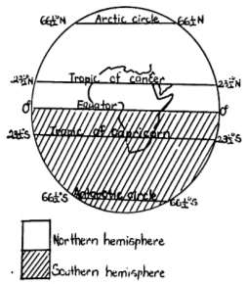

 **The Equator divides the world into two equal parts (hemispheres)**

 **The Equator is marked 0⁰ because it is the starting point for all latitude readings.**

 **The Equator is the most important line of latitude because it crosses the world at the centre.**

 **All countries which are crossed by the equator**

**lie in both the Northern and Southern hemisphere.**

 *A hemisphere* **is a half part of the world as divided by the equator or prime meridian.**

 **The area between the Tropic of cancer and the**

**Tropic of Capricorn is called the**  *Tropical region*.

 **The equator crosses lake George and lake**

**Victoria in Uganda.**

**Learning activity.**

**Use the political map of East Africa in your Atlas and identify all East African countries that;**

*(i) are crossed by the Equator.*

*(ii) completely lie in the Northern hemisphere*

*(iii) completely lie in the Southern hemisphere.*

*(iv) lie in both the Northern and the Southern hemisphere*

**Note:**

✓ *During the revolution of the earth around the sun, the sun is overhead the Equator on March 21st*

*and September 23rd.This period is called Equinox.*

✓ *The revolution of the earth is the movement of the earth around the sun.*

✓ *The revolution of the earth causes changes in seasons.*

✓ *During this time, the night and day time period worldwide is equal, sometimes high temperatures is experienced and heavy rainfall is received along the equator.*

✓ *Tropical region is the area of land lying between the Tropic of cancer and Tropic of*

*Capricorn.*

✓ *Equinox is the time of the year when the sun is overhead the equator.*

✓ *Solstice is the time of the year when the sun is overhead the tropics.*

**A diagram showing the time when the sun is overhead major lines of latitude.**

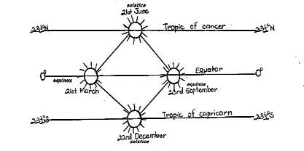

 **As the earth revolves the earth/moves around (orbits) the sun, it is tilted at 0º. The point**

**is in a fixed direction.**

 **Therefore in March and September the areas along the equator point towards the sun and receive sunlight for long hours causing a lot of heat in those places.**

 **The revolution of the earth takes 365 days(1 year). Effect of the earth’s revolution.**

**-It causes changes in seasons e.g spring, autumn, winter and summer seasons**

**NB:***Uganda experiences only two seasons i.e.wet season and dry season.*

**The rotation of the earth**

 **The rotation of the earth is the turning of the earth on its axis. It takes 24 hours for the earth to make a complete turn.**

 **The rotation of the earth is seen in the rising and setting of the sun.**

 **Places far in the East see the sun earlier than those in the West because the earth rotates from West to East.**

 **The Rotation of the earth on its axis causes days and nights. Other effects of the rotation of the earth**

❖ **It causes formation of tides.**

❖ **It causes ocean currents.**

**Neighbours of the EAC crossed by the equator**

❖ **It changes the direction of wind.**

❖ **Somalia** ❖ **Democratic Republic of Congo(D.R.C) Importance of lines of latitude.**

❖ **They help to determine the climate of an area.**

**LINES OF LONGITUDE**

 **These are imaginary lines drawn on a map or globe from the North pole to the South pole.**

 **Longitude is the distance in degrees East or West of the Prime meridian.  Meridians is the general name given to lines of longitude.**

**Major lines of longitudes**

❖ **Prime meridian/Greenwich meridian (0º)**

❖ **International Date Line (180ºE or W of the Prime meridian)**

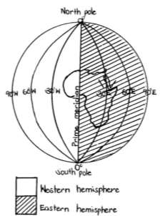

*The Prime meridian/ Greenwich meridian*

 **The Prime meridian is also called the Greenwich meridian**

**because it crosses Greenwich town in London.**

 **The Prime meridian is marked 0⁰ because it is the starting point for all longitude readings.**

 **The Prime meridian divides the world into the Eastern**

**and Western hemisphere.**

 **All countries crossed by the Prime meridian lie in both the Eastern and Western hemisphere.**

**Countries in Africa crossed by the prime meridian**

**-Algeria -Mali -Ghana -Burkina Faso**

**NOTE;**

❖ *Accra, Ghana is a city in West Africa which is crossed by the Prime meridian.*

❖ *The Prime meridian helps in telling international time.*

❖ *The International dateline separates one day from the next day.*

*e.g. East of the Greenwich meridian may be Friday while*

*West of it is Thursday.*

*East africa completely lies in the Eastern hemisphere.*

❖ *Lines of longitude help to determine time zones.*

❖ *Both lines of longitude and lines of latitude help in locating places on a map.*

**Location of lines of longitude and lines of latitude on the map of East Africa.**

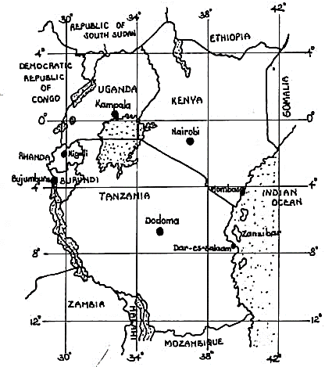

**00**

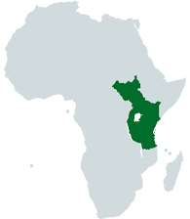





**00 *Equator* 00**

**00**

*Location of the EAC member states on the map of Africa*

**Finding time according to Greenwich Mean Time (G.M.T)**

 **The earth makes a full rotation of 360º in 1 day(24hours). Therefore the earth moves 15º**

**in every 1 hour.**

 **Every 15ºEor W of the prime meridian is a time zone.**

 **Different regions in the world have different time zones according to the distance from the prime meridian.**

 **Places in the same time zone have the same standard time.**

 **East African countries like Uganda, Kenya and Tanzania have the same time because they lie in the same time zone. The time zone for Uganda, Kenya, and Tanzania is known as the East African Standard Time. The three countries lie at longitude 45º.**

**How to calculate time using the lines of longitude.**

**Points to note when calculating time in any given country.**

✓ *When you travel 15*⁰ *westwards, you lose an hour while travelling 15*⁰ *eastwards makes you*

*gain an hour.*

✓ *We usually add (+) hours for places which are in the East and subtract (-) the time when*

*finding the time for places which are in the West.*

✓ *Changing of the time to and from 24hr clock (by either adding or subtracting 12 hrs) affects the units in which the time is given.(ie. From am to pm and viceversa).*

✓ *Time in each time zone is calculated basing on the Greenwich mean time (GMT) which is at 0*⁰

*longitude.*

**Example 1.**

**Find the time in East Africa which is 45**⁰ **if it is 2:00pm at GMT.**

*Solution,*

**15**⁰**=1hr**

**OR:**

**45**⁰**=(**

**) hrs.**

**2pm 3pm 4pm 5pm**

**=3hrs**

**0⁰ 15⁰ 30⁰ 45⁰**

**Time in East Africa=2:00pm**

**+3.00hrs**

Prime meridian

(GMT)

East

Africa

**5:00pm**

*Therefore, time in East Africa is 5:00pm.*

**Example 2.**

*Therefore, time in East Africa is 5:00pm*

**What time will it be in a country which is 60**⁰**W if it is 2:00pm in Ghana?**

*Solution,*

**15**⁰**=1hr**

**60**⁰**=(**

**) hrs**

**OR:**

**=4hrs**

**Time in that coutry is = 2:00pm (+12hours)**

**-4.00hrs**

**60⁰**

**10am 11pm 12pm 1pm 2pm**

**45⁰ 30⁰ 15⁰**

**0⁰**

**=14.00hrs**

**-4.00hrs**

Country

Ghana

**10:00am**

*Therefore, the time in that country will be 10:00am.*

*Therefore, time in that country will be 10:00am*

THE HISTORICAL BACKGROUND OF THE EAST AFRICAN COMMUNITY.

 **The East African Community is a group of countries in Eastern Africa that are united to promote trade. It is an example of common markets or regional groupings.**

 **It is an inter-governmental organisation meaning it brings several states together.**

 **The EAC was formed on 1st December 1967 to replace the East African Common Services**

**Organisation. The East African Common Services organisation had been formed in 1961.  The EACSO had its headquarters at Nairobi in Kenya.**

 **The EACSO replaced the East African High Commission (EAHC) which had been formed in**

**1946 after the second world war.**

 **Creech Jones, the British colonial secretary in East Africa by then, advocated for the formation of the EAHC.**

**The EAC as a common market**

 **A Common market is an organisation that brings countries together with an aim of promoting trade.**

 **It can also be called a regional economic grouping or an economic bloc.**

**Founders of the East African Community**

|  |  |  |
| --- | --- | --- |
|  |  |  |
| *Apollo Milton Obote* | *Jomo Kenyatta* | *Julius Nyerere* |

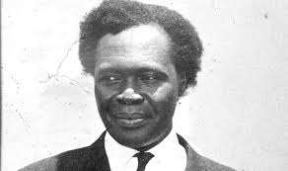

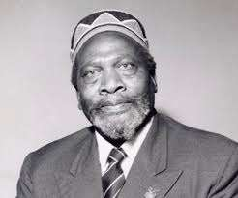

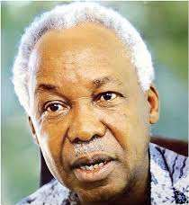

**Location of the founder members of the East African Community**

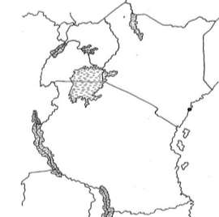

|  |  |
| --- | --- |
| Founder member of EAC | Founder of EAC |
| • **Uganda**  • **Kenya**  • **Tanzania** | • **Dr.Apollo Milton Obote**  • **Mzee Jomo Kenyatta**  • **Mwalimu Julius Kambarage Nyerere.** |

**UGANDA**

**KENYA**

**TANZANIA**

**Reasons for the formation of the East African Community (Objectives/ Aims of EAC)**

❖ **To promote regional trade.**

❖ **To set up a similar currency value.**

❖ **To have common taxes on goods for similar prices.**

❖ **To equally share the services of the former East African Common Services Organisation.**

❖ **To widen market for goods from member states.**

❖ **To promote cooperation and unity among the member states.**

❖ **To promote easy movement of goods and people across borders of the member states.**

**Departments of the former East African Community and the services they provided.**

|  |  |  |
| --- | --- | --- |
| Department | Headquarters | Services Provided |
| **East African Development**  **Bank (EADB)** | **Kampala** | **-It funded developmental projects of the**  **member states.**  **-It provided loans to member states.** |
| **East African Flying School**  **(EAFS)** | **Soroti** | **-It trained pilots of the East African Airways.** |
| **East African Airways (EAA)** | **Nairobi** | **-It provided air transport.**  **-It was responsible for development of**  **airports and airfields.** |
| **East African Examinations**  **Council (EAEC)** | **Nairobi** | **-It was responsible for setting, marking and**  **releasing examination results.** |
| **East African Railways and**  **Harbours(EARH)** | **Nairobi** | **-It dealt with railway and water transport.** |
| **East African Posts and**  **Telecommunication**  **Cooperation (EAPTC)** | **Kampala** | **-It provided telephone services and delivered**  **letters and parcels.** |

**Other departments of the defunct EAC.**

❖ **East African Income Tax- Nairobi**

❖ **East African Industrial Research- Nairobi**

❖ **East African Meteorological Department- Nairobi**

❖ **East African Customs and Excise Duty- Mombasa**

❖ **East African Marine Fisheries Research- Zanzibar**

❖ **East African Institute of Medical Research- Mwanza**

❖ **East African Civil aviation Board- Arusha**

❖ **East African Virus Research Institute- Entebbe**

❖ **East African Railway Repair Workshops- Kisumu**

❖ **East African Fresh Water Fisheries Research- Jinja**

❖ **East African Trypanosomiasis Research- Tororo**

❖ **East African Literature Bureau- Nairobi**

❖ **East African School of Library and Information Science- Nairobi**

**Achievements of the former EAC 1967-1977.**

❖ **It helped to start industrial projects through the EADB.**

❖ **It promoted regional cooperation through its common services.**

❖ **It promoted peace and unity among the member states.**

❖ **It created a wider market for goods from member states.**

**THE COLLAPSE/DISINTEGRATION OF THE EAST AFRICAN COMMUNITY IN 1977**

**Reasons why the EAC collapsed**

❖ **Political and ideological difference.**

❖ **Declaration of Idi Amin Dada to take control of the Western part of Kenya.**

❖ **Harassment of Kenyans in Tanzania**

❖ **Misunderstandings among the three heads of state of the EAC.**

❖ **Economic imbalances / unequal distribution of resources among the member states .**

❖ **Shortage of funds to facilitate its activities.**

❖ **The closure of border between Kenya and Tanzania.**

**Heads of state of the EAC member states at the time of its collapse.**

• **Idi Amin dada**

• **Jomo Kenyatta**

• **Julius Kambarage Nyerere**

|  |  |  |
| --- | --- | --- |
|  |  |  |
| *Idi Amin Dada* | *Jomo Kenyatta* | *Julius Nyerere* |

**Effects of the collapse of the EAC**

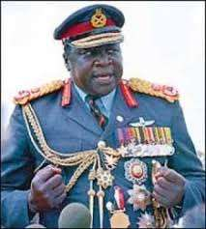

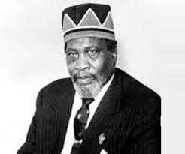

❖ **It led to decline in trade.**

❖ **It restricted the movement of people and goods in East Africa.**

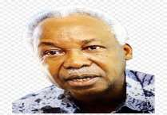

❖ **It led to mistreatment of people from member states .**

❖ **It led to enmity among the East African countries.**

❖ **The community assets were shared.**

❖ **It became difficult for Uganda to access her neighbours’ sea ports.**

**Departments that survived the collapse of the EAC.**

• **East African Development Bank.**

• **East African Flying School**

• **East African School of Library and Information Science. Problems that were faced by the East African Community.**

❖ **Shortage of funds to run its activities.**

❖ **Political and ideological difference.**

❖ **Military coup in Uganda.**

❖ **Production of similar goods.**

❖ **Internal conflicts.**

❖ **Absence of a common language.**

❖ **Absence of a common currency.**

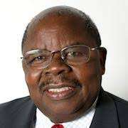

**REVIVAL OF THE EAST AFRICAN COMMUNITY IN 2001.**

 **The final agreement to revive the East African Community was signed on 30th**

**November,1999.**

 **It was signed at Amri Abeid Memorial stadium in Tanzania. Note:**

**-***The East African Community was called the East African Cooperation from 1993-1999.*

**Presidents who revived the East African Community.**

• **Yoweri K. Museveni of Uganda.**

• **Daniel Arap Moi of Kenya.**

|  |  |  |
| --- | --- | --- |
|  |  |  |
| *H.E Yoweri Museveni* | *Daniel Arap Moi* | *Benjamin Mkapa* |

• **Benjamin Mkapa of Tanzania.**

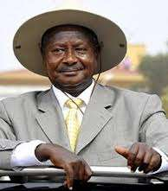



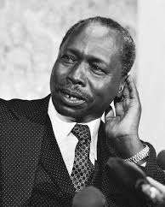

**Reasons why the East African Community was revived.**

❖ **To have common taxes on goods.**

❖ **To reduce smuggling of goods.**

❖ **To have a common currency in East Africa.**

❖ **To promote peace and security in the region.**

❖ **To promote cooperation and unity among the member states.**

❖ **To promote easy movement of people and goods across borders of the member states.**

❖ **To reduce on trade barriers.**

**The Expansion of the East African Community**

• **Rwanda in 2007**

• **Burundi in 2007**

• **South Sudan in 2016**

**Reasons why Rwanda, Burundi and South Sudan joined the East African Community.**

❖ **To easily handle oversea goods through port Dar-es -salaam and Mombasa.**

❖ **To enjoy free movement of people and goods among member states.**

❖ **To get a wider market for their goods.**

❖ **To get some goods they do not produce.**

❖ **To promote cooperation and friendship with their neighbours.**

**The current member states of the East African Community.**

|  |  |  |  |  |
| --- | --- | --- | --- | --- |
| Country | Capital City | President | Currency Used | Area of land (km2) |
| **Tanzania** | **Dodoma** | **John Pombe Magufuli** | **Tanzanian shilling** | **945,087** |
| **Uganda** | **Kampala** | **Yoweri Kaguta Museveni** | **Ugandan shilling** | **241,037** |
| **Kenya** | **Nairobi** | **Uhuru Kenyatta** | **Kenyan shilling** | **580,367** |
| **Rwanda** | **Kigali** | **Paul Kagame** | **Rwandan Franc** | **26,338** |
| **Burundi** | **Gitega** | **Evariste Ndayishimiye** | **Burundian Franc** | **27,834** |
| **South Sudan** | **Juba** | **Salva Kiir Mayardt** | **South Sudanese pound** | **619,745** |

**Note:-***The largest country among the EAC member states is Tanzania.*

*-The smallest country among the EAC member states is Rwanda.*

**A map showing the location of the current East African Community member states.**

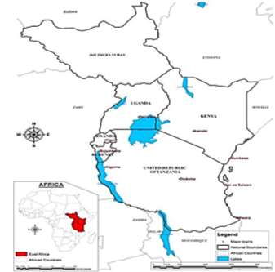



**Sudan**

South Sudan

**Ethiopia**

**Democratic**

**Republic of**

**Congo**

Uganda

Kenya

**Somalia**

Tanzania

**Zambia**

**Malawi**

**Indian ocean**



**Mozambique**

**Benefits of the East African Community.**

**a) To an individual/ people of East Africa.**

❖ **It has created employment opportunities for people.**

❖ **People are able to get goods that is not produced in their countries.**

❖ **It has widened market for traders’ goods.**

❖ **It has allowed free movement of people and goods across borders.**

❖ **It has reduced taxes imposed on their imported goods.**

**b) To member states of EAC.**

❖ **It has promoted cooperation and unity among member states.**

❖ **It has promoted peace and stability in the member states.**

❖ **It has created a wider market for goods produced in the member states.**

❖ **It has enabled land locked member states to access sea ports.**

**c) To non-member states of EAC.**

❖ **It has created a wider market for their goods.**

❖ **The EAC member countries provide skilled labour to non-member states of EAC.**

❖ **The EAC member countries provide security to non-member states of EAC.**

❖ **The EAC member states provide jobs to people from non-member states of EAC.**

**LAND LOCKED MEMBER STATES OF THE EAC**

 **A land locked country is a country without a coastline.**

 **Land locked countries are completely surrounded by other countries. Member states of EAC which are land locked.**

• **Uganda**

• **Burundi**

• **Rwanda**

• **South Sudan**

**Neighbouring countries of the EAC which are land locked.**

• **Ethiopia**

• **Malawi**

**Problems faced by land locked countries.**

❖ **Delay of oversea goods in transit.**

❖ **High taxes charged on imported oversea goods.**

• **Zambia**

• **Central African Republic (C.A.R)**

❖ **High transport costs when importing and exporting goods.**

❖ **High prices for imported goods.**

**Possible solutions for the above challenges.**

❖ **By joining the regional grouping.**

❖ **By improving on the air transport system.**

❖ **By encouraging local industrial production.**

❖ **By cooperating with non-land locked countries.**

❖ **By building modern road networks.**

❖ **By using various sea ports when importing and exporting goods.**

**NON-LAND LOCKED COUNTRIES.**

 **A Non-land locked country is a country which has coastline. Non-land locked member states of the EAC.**

• **Tanzania**

• **Kenya**

**Neighbouring countries of the EAC which are non-land locked.**

• **Mozambique**



• **Democratic Republic of Congo (D.R.C)**

• **Sudan**

• **Somalia**

**Major sea ports that handle East Africa’s goods.**

• **Port Mombasa**

• **Port Dar-es-salaam**

• **Port Matadi in Democratic Republic Of Congo**

**Benefits enjoyed by non-land locked countries.**

❖ **They pay low taxes on imported goods.**

❖ **Their oversea goods do not delayed in transit.**

❖ **They meet less transport costs when importing their oversea goods.**

❖ **They get taxes through taxing goods of land locked countries that pass through them.**

ORGANS OF THE EAST AFRICAN COMMUNITY.

• **The Summit**

• **The Council of Ministers**

• **The Secretariat**

• **The East African Legislative Assembly (EALA) The Summit**

➢ **It is the topmost organ of the EAC.**

• **The East African Court of Justice (EACJ)**

• **The Coordinating committee**

• **The Sectoral committee**

➢ **It is composed of the heads of state of the EAC member states.**



➢ **Its main role is to direct the activities of the EAC.**

➢ **It is headed by the chairperson.**

➢ **The current chairperson of the EAC is .**

**The Secretariat.**

➢ **The secretariat is based in Arusha, Tanzania.**

➢ **It is headed by the secretary general.**

➢ **It runs the daily affairs of the EAC.**

➢ **The current secretary general is Dr. Liberat Mfumukeko.**

**Duties of the secretary general.**

❖ **To administer and manage the finances of the EAC.**

❖ **To give information on the community programmes to stake holders and general public.**

❖ **He/she monitors the community activities.**

❖ **Mobilises funds from development partners to implement community projects.**

❖ **Prepares and submits the budget of the EAC.**

**Secretary Generals of the EAC from 1996**

|  |  |  |
| --- | --- | --- |
| Name | Year | Country |
| **Francis Muthaura** | **1996-2001** | **Kenya** |
| **Amanya Mushega** | **2001-2006** | **Uganda** |
| **Juma Mwapachu** | **2006-2011** | **Tanzania** |
| **Dr. Richard Sezibera** | **2011-2016** | **Rwanda** |
| **Dr.Liberat Mfumukeko** | **2016-to date** | **Burundi** |

**The Council of Ministers.**

➢ **It is composed of ministers of foreign affairs from each member state.**

➢ **Its role is to make decisions on behalf of the summit.**

➢ **It monitors the implementation of the EAC policies.**

**The Sectoral committee.**

 **Its members are appointed by the council of ministers.**

➢ **It prepares development programmes.**

➢ **It monitors the implementation of the policies of the EAC.**

**The Co-ordinating committee.**

 **It consists of the permanent secretaries for ministers of regional co-operation from each**

**member state.**

 **It reports to the council of ministers.**

➢ **It implements the decisions of the council of ministers.**

➢ **It coordinates the activities of the sectoral committee.**

**East African Legislative Assembly (EALA)**

➢ **It serves as the parliament of the EAC.**

➢ **It makes laws for the EAC.**

➢ **It discusses and approves the EAC budget.**

➢ **It is made up of members of parliament, 9 from each member state.**

➢ **It is headed by the speaker.**

➢ **The current speaker of the EAC is Hon. Martin Ngoga.**

**Speakers of EALA since the revival of the EAC.**

|  |  |  |
| --- | --- | --- |
| Name | Year | Country |
| **Abdulrahman Kinana** | **2001-2006** | **Tanzania** |
| **Abdirahim Abdi** | **2006-2011** | **Kenya** |
| **Margaret Nantogo Zziwa** | **2012-2014** | **Uganda** |
| **Hon.Daniel Fred Kidega** | **2014-2017** | **Uganda** |
| **Hon.Martin Ngoga** | **2017-present** | **Rwanda** |

**The East African Court of Justice.**

➢ **It is headed by the president.**

➢ **The current president of the EACJ is Emmanuel Ujirashebuja.**

➢ **It promotes human rights among the EAC member states.**

➢ **It settles disputes among member states.**

**Departments of the current East African Community.**

• **Lake Victoria Basin Commission (LVBC)**

• **Inter-University Council of East Africa(IUCEA)**

• **Civil Aviation Safety and Security Oversight Agency.(CASSOA)**

• **Lake Victoria Environment Programme (LVEP)**

• **Lake Victoria Fisheries Organisation (LVFO)**

• **East African Development Bank (EADB)**

• **East African Flying School (EAFS)**

**Problems/ challenges facing EAC as a common market**

❖ **Lack of a common language.**

❖ **Shortage funds to finance its activities.**

❖ **Production of similar goods.**

❖ **Absence of a common currency.**

❖ **Desire for prestige by some member states.**

❖ **Political differences among member states.**

❖ **Political instability in some among member**

**states.**

❖ **Importation of low quality goods.**

❖ **Poor transport and communication.**

**Suggested solutions to challenges facing common markets in east Africa**



❖ **By forming a joint army to promote security in the region.**

❖ **By forming economic partnerships with other regional groupings.**

❖ **By adopting a common language like Kiswahili.**

❖ **By promoting good governance and democracy in the region.**

❖ **By improving the transport and communication network.**

**Ways regional bodies promote trade.**

❖ **By promoting free trade zones.**

❖ **By promoting peace and security in the region.**

❖ **By organising trade fares.**

❖ **By widening market for goods and services.**

❖ **By developing a common taxation policy.**

❖ **By promoting free movement of people and goods across borders of the member states..**

❖ **By developing a common currency.**

SYMBOLS OF THE EAST AFRICAN COMMUNITY.

• **The EAC flag**

• **The EAC anthem**

• **The EAC constitution**

• **The EAC motto**

• **The EAC emblem**

**The East African Community Flag**

➢ **The EAC has six colours and an emblem in the middle.**

➢ **The Blue background represents the waters of lake Victoria.**

➢ **White, Black, Green, Yellow, and Red colours are taken from the flags of the EAC member states to signify their**

**cooperation.**

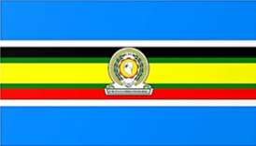

**Places where the EAC flag can be raised.**

• **Schools**

• **Embassies and High Commissions of the**

**Member States**

• **Airports**

• **Hospitals**

• **Public offices**

**Note:-***The EAC motto is One People One Destiny. It encourages unity among people of the EAC.*

**Importance of the EAC flag.**

❖ **It promotes regional unity.**

❖ **It promotes regional identity.**

**The EAC emblem.**

❖ **It promotes patriotism.**

➢ *A Map of East Africa in the middle of the EAC*

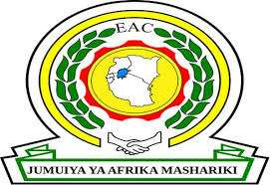

*emblem. It reminds of the EAC cooperation.*

➢ *The industrial wheel represents the industrial growth as a common goal in the region.*

➢ *The arch of leaves represents the rich vegetation and agricultural production among the member*

*states.*

➢ *The hand shake represents unity and friendship among the member states.*

➢ *The words “JUMUIYA YA AFRIKA*

*MASHARIKI” translated as “East African Community” means the cooperation of the countries of East Africa.*



**THE EAST AFRICAN COMMUNITY ANTHEM.**

 **It is called Wimbo wa Jumuiya ya Afrika Mashariki.**

 **The EAC anthem started to be used on 3rd December 2010.**

 **It has three stanzas.**

 **It was composed by;**

▪ **John Mugango from Tanzania.**

▪ **Wasswa Joseph from Uganda.**

▪ **Richard Kadhambi from Kenya.**

**Occasions where EAC anthem is sung**

▪ **School assemblies**

▪ **During parliamentary sessions.**

**Importance of the EAC anthem.**

❖ **It promotes regional unity.**

❖ **It promotes love for God.**

▪ **At official ceremonies**

▪ **Start of public functions.**

❖ **It promotes patriotism and hard work.**

❖ **It promotes friendship among the EAC member states. EAST AFRICAN COMMUNITY ANTHEM**

*Kiswahili Version*

Stanza 1

**Ee Mungu twaomba ulinde Jumuiya Afrika Mashariki Tuwezeshe kuishi kwa amani Tutimize na malengo yetu**

Chorus

**Jumuiya Yetu sote tuilinde**

**Tuwajibike tuimarike**

**Umoja wetu ni nguzo yetu**

**Idumu Jumuiya yetu.**

Stanza 2

**Uzalendo pia mshikamano**

**Viwe msingi wa Umoja wetu**

**Natulinde Uhuru na Amani**

**Mila zetu na desturi zetu.**

Stanza 3

**Viwandani na hata mashambani Tufanye kazi sote kwa makini Tujitoe kwa hali na mali Tuijenge Jumuiya bora.**

*English Version*

Stanza 1

**Oh God we pray**

**For preservation of the East African**

**Community;**

**Enable us to live in peace; May we fulfill our objectives;**

Chorus

**We should protect/guard our community**

**We should be committed and**

**Stand strong**

**Our unity is our anchor**

**Long live our community**

Stanza 2

**Patriotism and togetherness**

**Be the pillars of our unity**

**May we guard our independence**

**And peace**

**Our culture and traditions**

Stanza 3

**Industries and farms**

**We should work together**

**We should work hard**

**We should build a better community.**

NATIONAL SYMBOLS OF EACH EAC MEMBER STATE.

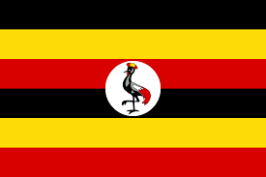



**UGANDA’S NATIONAL SYMBOLS THE UGANDA NATIONAL FLAG**

➢ **The Uganda National Flag was designed by Grace**

**Ibingira**

➢ **The Uganda national flag has three main colours**

**i.e. black ,yellow ,red.**

➢ **A crested crane in a white circular background is**

**at the centre of the flag. The white background represents peace.**

➢ **The Uganda national flag promotes national identity.**



**Meaning of each colour on the Uganda National Flag.**

❖ **Black represents the dark-skinned people of Uganda. It symbolises the African race of**

**Ugandans.**

❖ **Yellow represents the abundant sunshine received in Uganda.**

**It also represents the warm climate experienced in Uganda.**

❖ **Red represents the international brotherhood.**

❖ **White stands for the peace enjoyed in Uganda.**

**THE UGANDA NATIONAL COAT OF ARMS.**

➢ *Uganda coat of arms is composed of a shield and two spears on a green hill with the Uganda*

*kob on the left and the crested crane on the right. It is designed using symbols that summarise important ideas and things Uganda holds.*

➢ *It is found on official documents, the national*

*currency, parliament, the government seal and*

*the president’s official car.*

➢ *It is also hung in government institutions like courts and offices to symbolise power and authority.*

➢ *The Uganda coat of arms was designed by*

*Paul Mukasa.*

➢ *The Uganda coat of arms acts as a public seal of Uganda.*

➢ *The public seal is used to signify the official nature of government documents that bear its*

*stamp.*

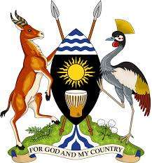

**Meaning of features found on the Uganda coat of arms.**

❖ **The spears and shield represents the traditional means of defence.**

❖ **The blue stripes at the top represents the water bodies in Uganda.**

❖ **The blue stripes at the bottom of the shield represent the source of River Nile found in**

**Uganda.**

❖ **The sun represents the abundant sunshine received in Uganda or warm climate experienced in**

**Uganda.**

❖ **The drum represents the traditional means of communication.**

**It also represents the culture of the people of Uganda.**

❖ **The black colour on the shield symbolises the African race of Ugandans.**

❖ **The kob represents the rich/abundant wildlife in Uganda.**

❖ **The crested crane represents the gentleness and peaceful nature of the people of Uganda.**

❖ **Coffee and cotton on the green hill show the traditional cash crops grown in Uganda.**

**It also shows that Uganda is an agricultural country.**

❖ **The green colour represents the abundant vegetation of Uganda.**

❖ **The green hill represents the many physical features of Uganda.**

❖ **The national motto “For God and My Country” signifies that the people of Uganda are God fearing.**

**THE UGANDA NATIONAL ANTHEM**

1.

Oh Uganda! may God uphold thee, We lay our future in thy hand. United, free,

For liberty

Together we'll always stand.

2.

Oh Uganda! the land of freedom. Our love and labour we give,

And with neighbours all

At our country's call

In peace and friendship we'll live.

3.

Oh Uganda! the land that feeds us

By sun and fertile soil grown. For our own dear land,

We'll always stand:

The Pearl of Africa's Crown.

➢ **“Oh Uganda, land of beauty” is the country’s official song. It was composed by George Wilberforce Kakoma.**

➢ **It was first officially sung on independence day on 9th**

**October 1962 by Makerere college school choir,**

**conducted by a student Catherine Mwandha.**

➢ **The Uganda national anthem is sung and played during**

**official functions. It symbolises the country’s**

**principles, hopes and goals.**

➢ **The Uganda national anthem has three stanzas . All**

**the three stanzas are sung to open and close official and important functions.**

*NOTE:*

✓ *If there are other anthems or prayers during a function, the national anthem is sung first, followed by other*

*anthems and then a prayer. At the end of the function,*

*other anthems are sung first and the national anthem is sung last to close the function.*

✓ *The Uganda national anthem promotes national unity.*

✓ *When singing the national anthem, people must stand at attention as a sign of respect.*

**The Uganda National Emblem.**

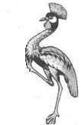

• **The crested crane is the Uganda’s national emblem. It signifies**

**the gentleness and peaceful nature of the people of Uganda.**

• **Its drawn when it is in motion to show that Uganda is moving forward in terms of development**

**Why the crested crane was chosen to be Uganda’s national emblem.**

• **It is a beautiful bird.**

• **It is a gentle bird.**

• **It is a graceful bird.**

• **It is a peaceful bird.**

**THE NATIONAL FLAG AND COAT OF ARMS OF KENYA.**

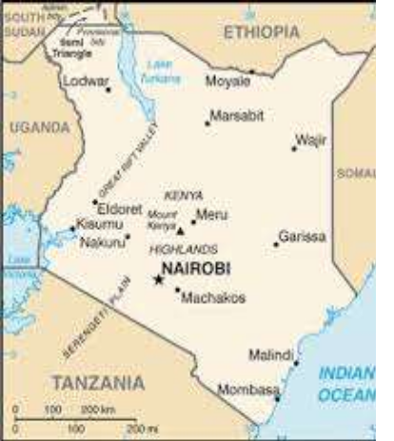

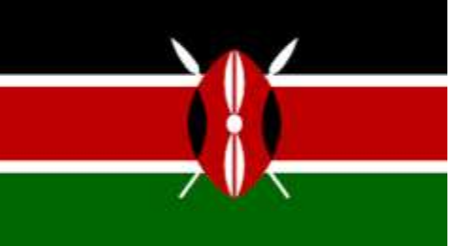

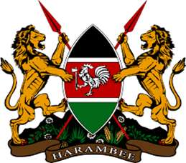

***Features on the Kenya national flag and their meaning****.*

***Features on the Kenya national coat of arms and their meanings.***

➢ *Black colour represents the people of Kenya who are predominant Africans.*

➢ *White colour represents the peace enjoyed in*

*Kenya.*

➢ *Red colour represents the blood that was shed*

*during the struggle for independence.*

➢ *Green colour represents the land and its*

*agricultural potential.*

➢ *Shield and spears represents the traditional*

*weapons and readiness to defend and protect the*

*country.*

➢ *Lions holding spears symbolises the courage, ability and strength of Kenyans to defend their country*

*against external attacks.*

➢ *Cockerel symbolises the party that led Kenya to*

*independence.*

➢ *Shield shows Kenya’s readiness to defend her*

*independence.*

➢ *Agricultural products represent Kenya’s rich fertile*

*soils.*

➢ *The motto ”Harambee” is a call for people to*

*cooperate and work together in building the nation.*

**THE NATIONAL FLAG AND COAT OF ARMS OF TANZANIA.**

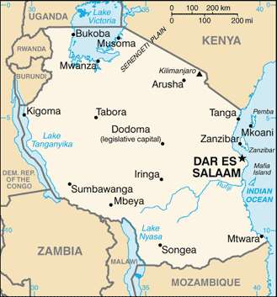

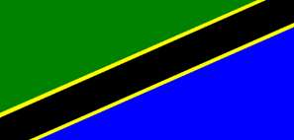

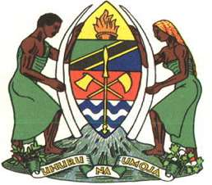

**Features of the Tanzania national**

**flag and their meaning**

**Features of the Tanzania coat of arms and their**

**meaning.**

• *Black colour represents the African race of Tanzanians.*

• *Green colour represents the abundant vegetation and fertile land of Tanzania.*

• *Blue colour represents the various lakes, rivers and other water bodies found in Tanzania.*

• *Golden colour represents the different minerals and other wealth found in Tanzania.*

• Golden colour represents the numerous minerals and other wealth which are found in Tanzania.

• Red colour represents the fertile soils on which different crops are found.

• Blue waves represents the different water bodies found in

Tanzania.

• Burning torch represents the freedom, independence and enlightment of the people of Tanzania.

• Spear and shield represents the readiness of Tanzanians to protect and defend their country.

• Axe and hoe represent the determination of Tanzania to promote agricultural development.

• Cotton and cloves represents the traditional cash crops of

Tanzania. They also represent Tanzania as an agricultural country.

• Man and woman each holding an elephant tusk: represents the cooperation of Tanzanians to develop their country.

• The motto of Tanzania:  **“Uh u r u n a u m o ja”** means freedom and unity.

**THE NATIONAL FLAG AND COAT OF ARMS OF RWANDA.**

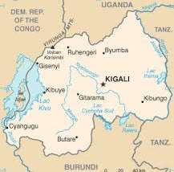

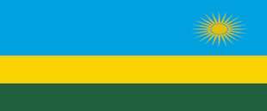

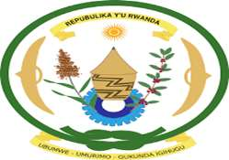

***Features on the Rwanda national flag and their meaning.***

• *Blue colour reperesents the peace and happiness enjoyed in Rwanda.*

• *Yellow colour represents the economic development and mineral wealth.*

• *Green colour represents Rwanda as an agricultural country with abundant vegetation.*

• *The sun represents unity and enlightment of the people of Rwanda.*

***Features on the Rwanda national coat of arms and their meaning.***

• *Green ring with a knot represents the determination of Rwandans to develop through hard work.*

• *Sorghum and coffee represents the agricultural potential of Rwanda.*

• *Basket represents the traditional handcrafts,culture of saving, solidarity and sharing.*

• *Cog wheel represents Rwanda’s readiness to develop in the field of*

*science,technology and industry.*

• *Shields represents the traditional means of defence. They also*

*represent patriotism and the people’s readiness to defend the country.*

• *The motto of Rwanda* ***“Ubumwe, Umurimo,Gukunda Iguhugu”*** *(Unity,work,and patriotism) represents the determination of Rwandans to work together in order to develop their country.*

**THE NATIONAL FLAG AND COAT OF ARMS OF BURUNDI.**

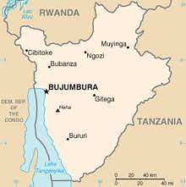



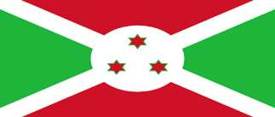

• ***Features on the Burundi national flag and their meaning***

• *Green colour represents the abundant natural resources in Burundi.*

• *White colour represents hope and peace.*

• *Red colour represents international brotherhood.*

• *The three stars represents the three ethnic groups in Burundi ,the Hutu,Tusti and Batwa.*

• ***Features on the Burundi national coat of arms.***

• *Shield and spears represents the readiness of the people of Burundi to defend and protect their country.*

• *National motto: Burundi’s motto is in French****.”Unite Travail Progres”(****Unity,Work,Progress.): it represents the unity and determination of the Burundians to work hard for the progress of their country.*

**THE NATIONAL FLAG AND COAT OF ARMS OF SOUTH SUDAN.**

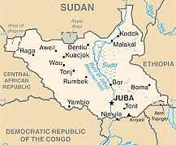

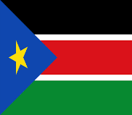

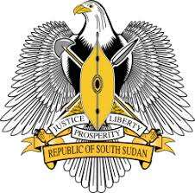

**..**

***Features on the national flag of South Sudan and their meaning.***

• *Black colour represents the African race of the people of South Sudan.*

• *Red colour represents the blood that was shed in the liberation struggle.*

• *Green colour represents the fertile land and natural resources.*

• *Blue colour represents the waters of River Nile.*

• *Yellow star represents the unity of states making up South South Sudan.*

***Features on the national coat of arms of South Sudan and their meaning.***

• *African fish eagle represents the people’s resilience, vision*

*and majesty.*

• *Shield and two spears represents the people’s readiness to*

*protect their country.*

• *The motto:* ***“Justice, Prosperity and Equality*** *.” represents the people’s aspirations to live in a fair and just society in their country.*

**Importance of national symbols**

❖ **They promote national identity. They make countries look different from other**

**countries.(they are used as symbols of identification.)**

❖ **They promote national unity eg.the anthem.**

❖ **They promote patriotism among people.**

❖ **They are used as symbols of independence.**

**The neighbouring countries of the EAC**

|  |  |  |
| --- | --- | --- |
| Country | Capital City | Direction |
| • **Republic of Sudan** | • **Khartoum** | • **North** |
| • **Mozambique** | • **Maputo** | • **South** |
| • **Malawi** | • **Lilongwe** | • **South** |
| • **Democratic Republic of Congo** | • **Kinshasa** | • **West** |
| • **Ethiopia** | • **Addis-Ababa** | • **North West** |
| • **Somalia** | • **Mogadishu** | • **East** |
| • **Central African Republic (C.A.R)** | • **Bangui** | • **North West** |
| • **Zambia** | • **Lusaka** | • **South West** |

Testing Exercise.



**1. Mention the commonest way of telling directions your community.**

**2. Give any two ways one can be able to locate places on a map.**

**3. Give the meaning of Lines of latitude.**

**4. Why are lines of latitude sometimes called “the parallels”?**

**5. Name the major line of latitude that crosses the East African Community member states.**

**6. What name is given to the region between the tropic of cancer and tropic of Capricorn?**

**7. Mention one neighbouring country of Uganda that lies in both the Northern and Southern hemisphere.**

**8. Why is the equator marked 00?**

**9. Give the meaning of the term Equinox.**

**10. State the effect of the Revolution of the earth around the sun.**

**11. Why do people living at Mombasa see the sun earlier than those ones at Kasese?**

**12. Mention the two months of the year when the sun is always overhead the equator.**

**13. What causes days and nights?**

**14. Name the line of longitude which helps in telling the international time.**

**15. Find the time in Rwanda which is 300W if it is 5:00pm in Ghana.**

**16. Name the British colonial secretary who advocated for the formation of the East African**

**Community.**

**17. State any three reasons for the formation of the EAC in 1967.**

**18. Mention the three founder members of the EAC.**

**19. Name the organisation which was replaced by the EAC.**

**20. Which common market unites all East African countries?**

**21. Mention any two departments of the defunct EAC which had their headquarters in Uganda.**

**22. State any one achievement of the defunct EAC before it collapsed.**

**23. State any three reasons for the collapse of the EAC in 1977.**

**24. Give any two ways the collapse of the EAC affected international trade in the region.**

**25. Name the three heads of state at the time of the collapse of EAC.**

**26. Mention any two departments of EAC which survived as EAC collapsed in 1967.**

**27. Why is 30th November, 1999 remembered in the history of East African Community?**

**28. Name the three heads of state who revived the East African Community.**

**29. Give any three reasons why the heads of state of East African countries revived the EAC.**

**30. Mention the newest member state of the East African Community.**

**31. Give any two reasons why the above country joined the East African Community.**

**32. State any three ways the people of East Africa benefit from the East African Community.**

**33. Why is Uganda referred to as a land locked country?**

**34. Mention any three land locked member states of the East African Community.**

**35. State any three problems land locked countries like Uganda face.**

**36. How is Uganda similar to Rwanda in terms of location?**

**37. Mention any two seaports that handle imports and exports of East African countries.**

**38. State any one benefit Kenya enjoys over Uganda due to her location.**

**39. Mention any four organs of the East African Community.**

**40. State any three problems facing the East African Community.**

**41. Give any two ways the East African Community member states can solve the above challenges.**

**42. Give any three ways the East African Community has promoted trade in East Africa.**

**43. Mention any three symbols of the East African Community.**

**44. Write down the East African Community motto.**

**45. What does the blue colour symbolise on the East African Community flag?**

**46. Mention any two occasions when the East African Community anthem is normally sung.**

**47. Give the English meaning of the phrase “Jumuiya ya Afrika Mashariki”.**

**48. Give one way a national anthem is important to a country.**

**49. What do the following features symbolise on the Uganda national coat of arms? (i) The Kob**

**(ii) The drum**

**(iii) Coffee and cotton**

**(iv) The sun.**

**50. Why was the crested crane chosen as Uganda’s national emblem?**